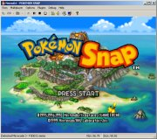
Nemu64 is one of the oldest Nintendo 64 emulators in existance. For a long time it was also nearly unplayable due to being to slow for most PCs to run. Fortunately as both Nemu64 and the development of faster multi-Ghz CPU's progressed, Nemu64 can be played without much slowdown.
For a while Nemu64 was the second best Nintendo 64 emulator available after UltraHLE. With the advent of Project64 and 1964 however it's lagging behind even futher. But as the screenshots indicate it is certainly possible to play games with Nemu64.
Nemu64's last release was March 2003 and there will probably not be a new version as it has been discontinued.

